ព្រះរាជាណាចក្រកម្ពុជា

ជាតិ​ សាសនា ព្រះមហាក្សត្រ

Institute of technology of Cambodia

Department of Information and communication Engineering



The lesson taking about using structure.

TP10- Structure

TP: Algorithm and Programming

Lecturer: BOU CHANNA

Student: VEN THON

ID: e20191250

Group: I3-GIC-C

Year: 2021-2022

Contents

Problem1: 3

Problem2: 4

Problem3: 5

Problem4: 7

# Problem1:

Create a client structure. Data of a client has clientID, gender, name, and phone. Then write a program to

a- Create one variable for store info of a client. Then ask a user to input information.

b- Display client's info on screen.

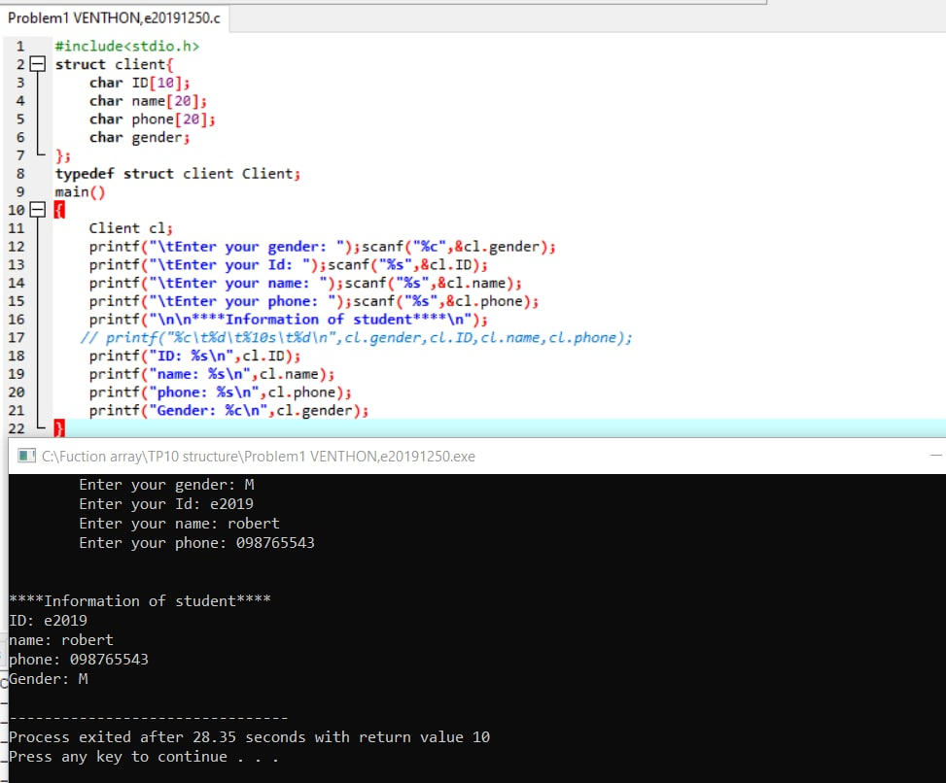

# Problem2:

Create a structure for client structure as given in problem #1. Then

- Create an array that can store data of 10 clients.

- Using loop to get data of 10 clients and store in array.

- Diplay all data of clients

clientID gender Name Phone

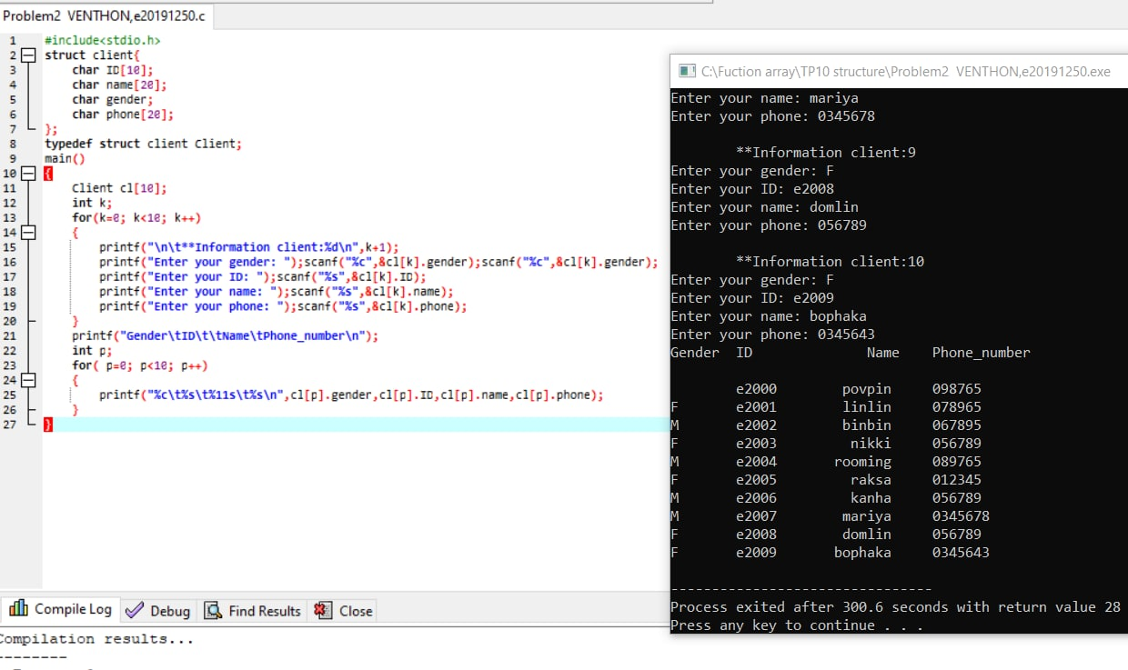

# Problem3:

Create two structure address (street number, house number, village, district) and student (student ID, citizen ID, name, major, university name, address, age). Then create an array of type student. Write a program to

a- Get 6 student info and store in the array.

b- Display all data in the array.

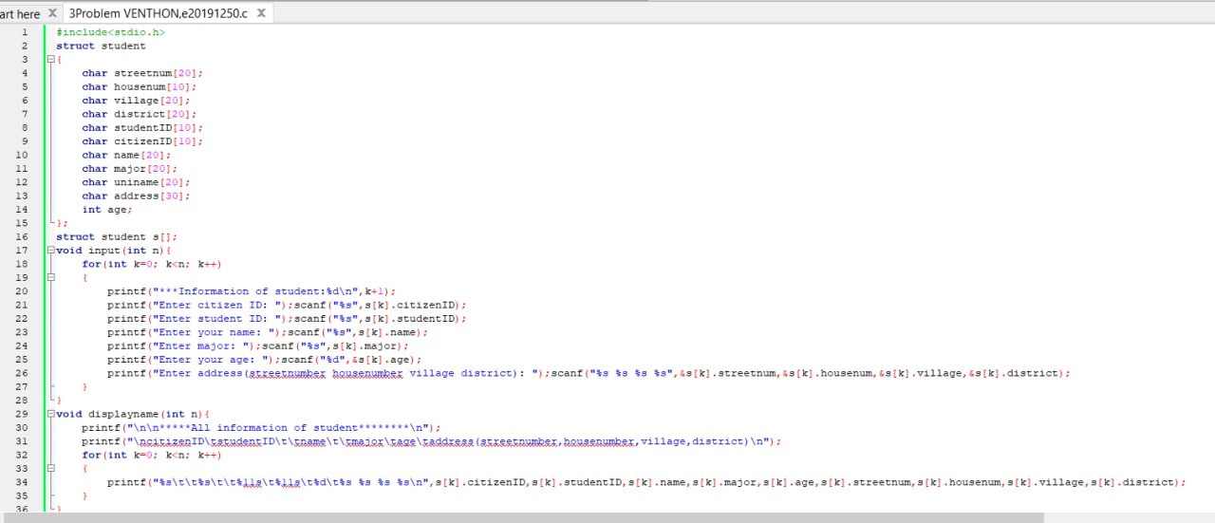c- Show who are the youngest and oldest students.

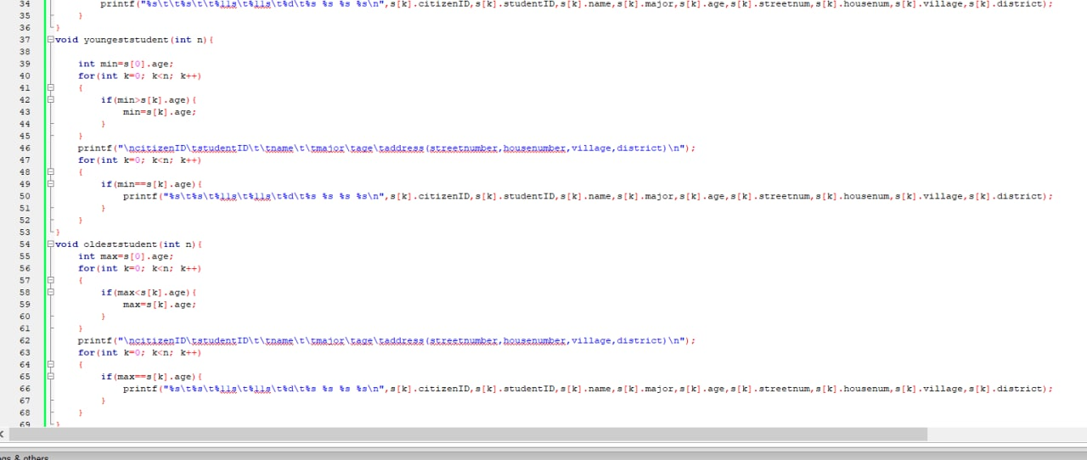

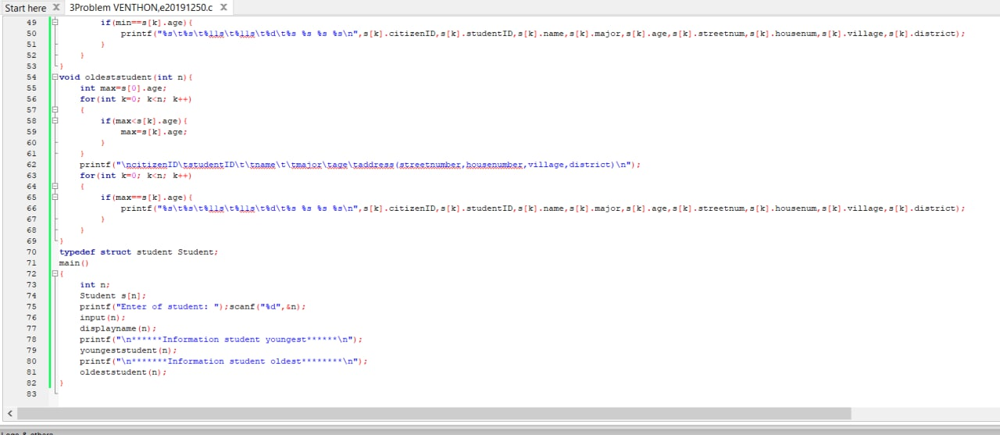

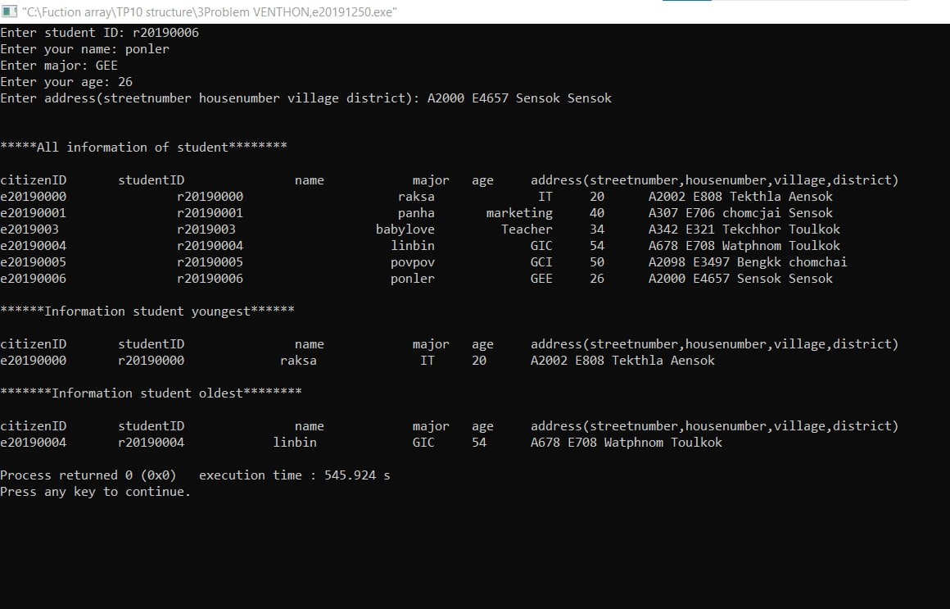

# Problem4:

Write a C program to keep records and perform statistical analysis for a class of 20 students. The information of each student contains ID, Name, Sex, quizzes score (20), mid-term score (40), and final score (40), and total score.

The program prompts the user to choose the operation of records from a menu as shown below:

====================

       Menu

====================

1. Add 2 students

2. View all student records

3. Show student who gets the max total score

4. Display student by ID (search by an ID)

5. Find min, max, and average scores for this class.

--------------

Choose your option 1-5:

